**Values’ distribution of the all layers. from left to right: BN’s input, pure BN (before affine), BN’s output (after affine). On miniImageNet** 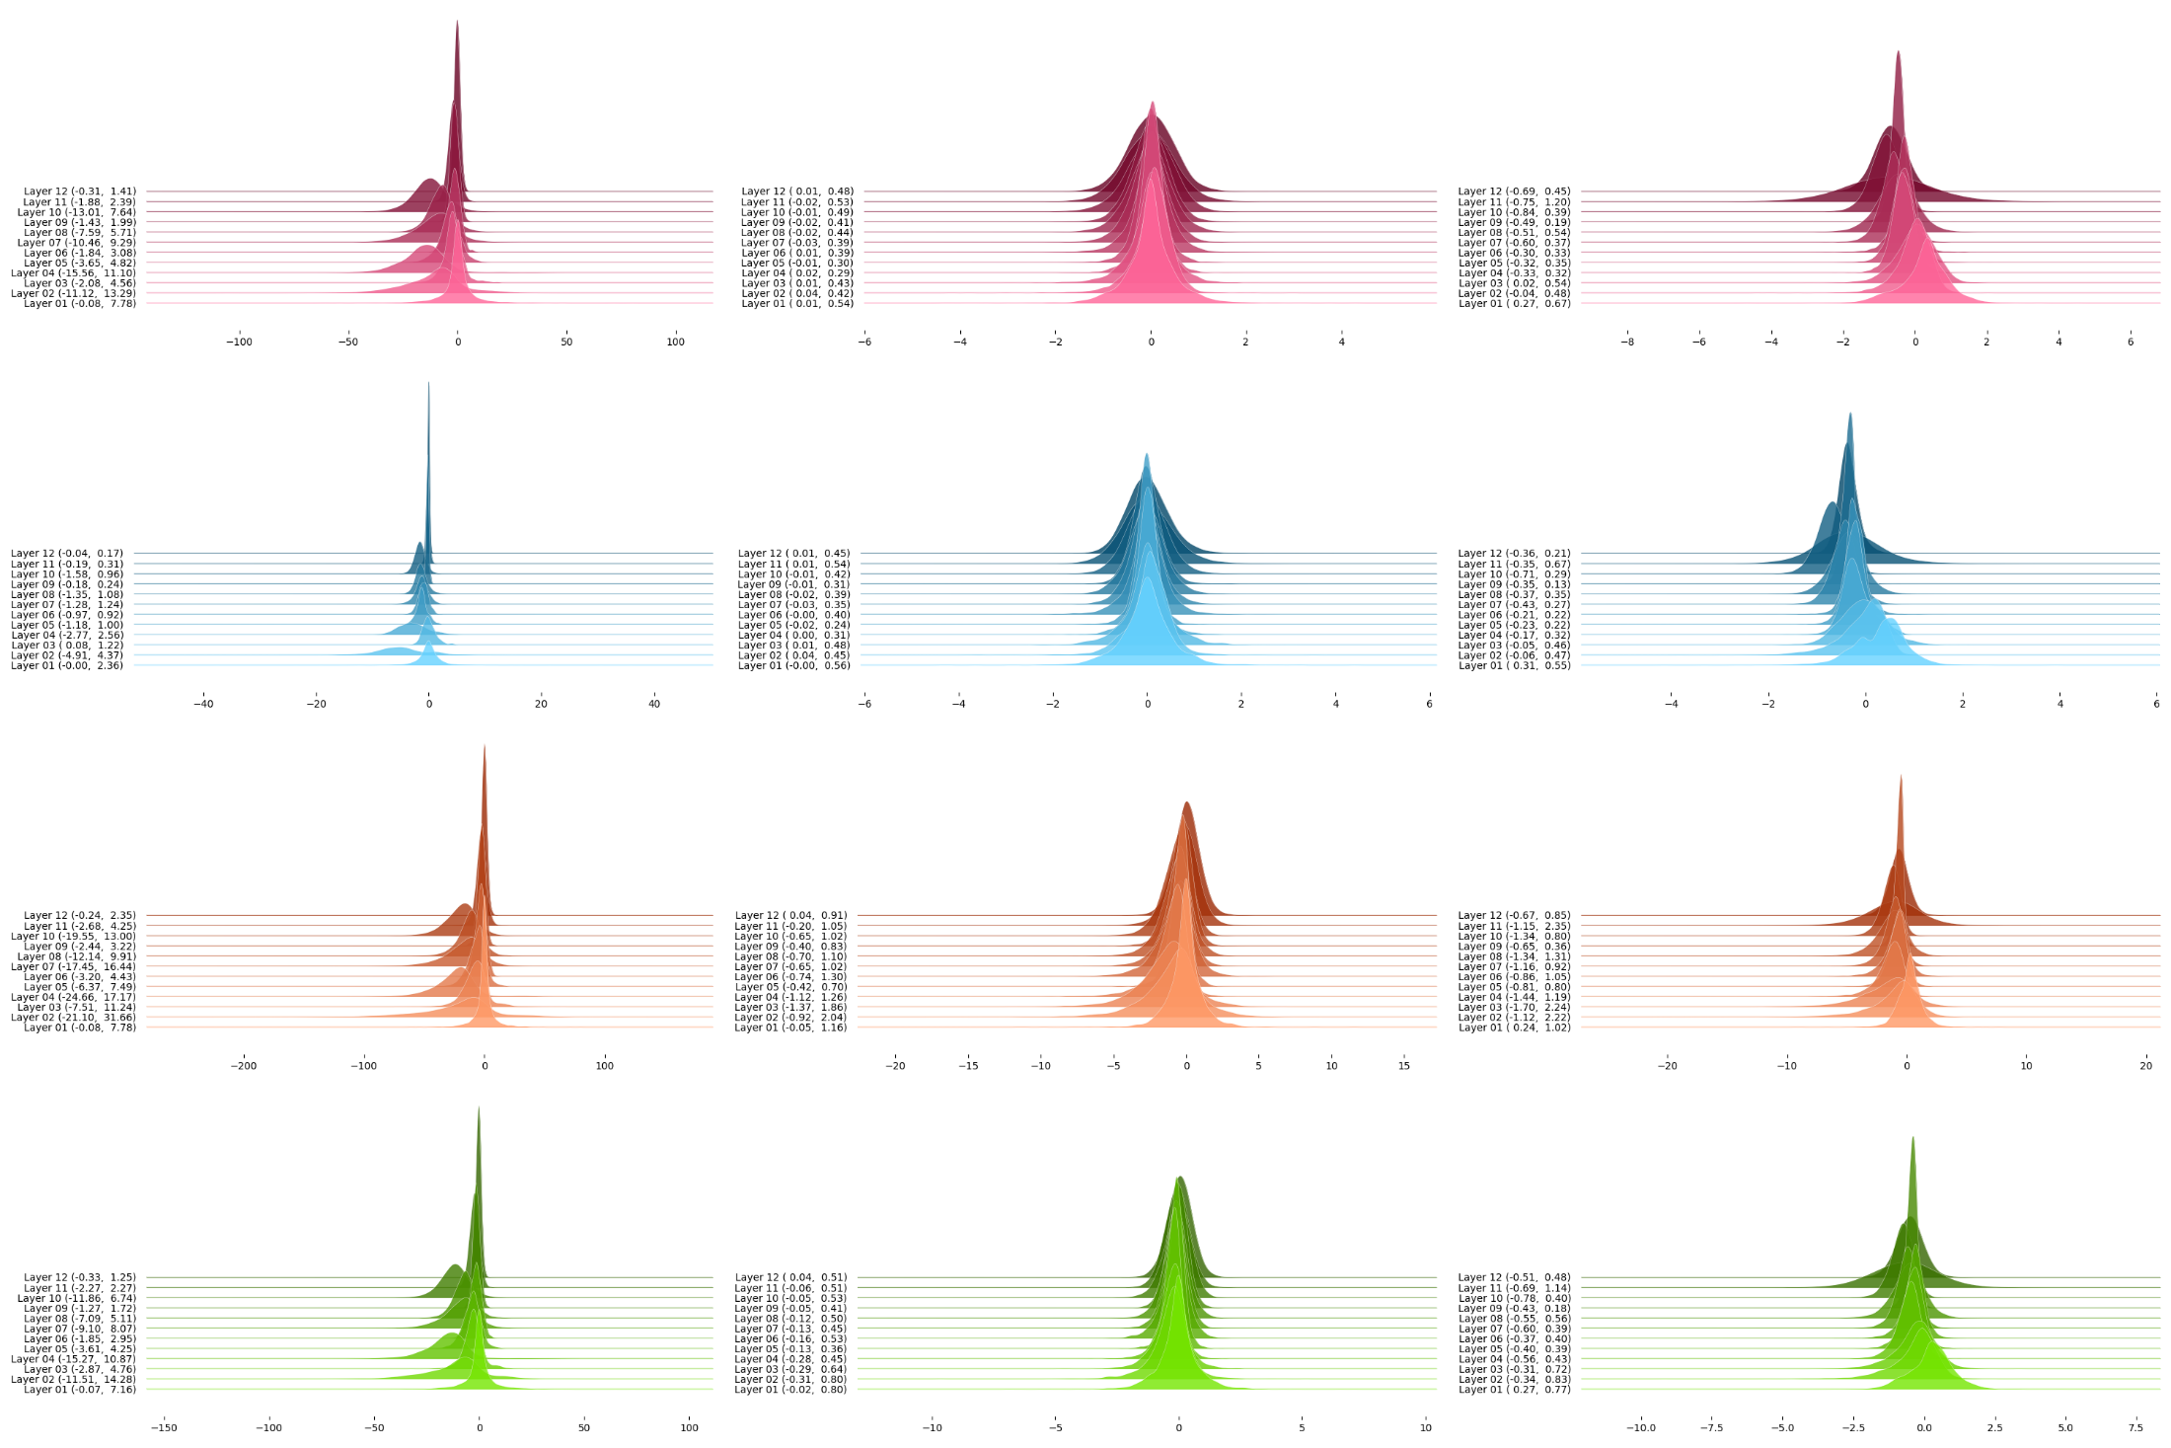

**Values’ distribution of the layer 2. from left to right: BN’s input, pure BN (before affine), BN’s output (after affine). On miniImageNet**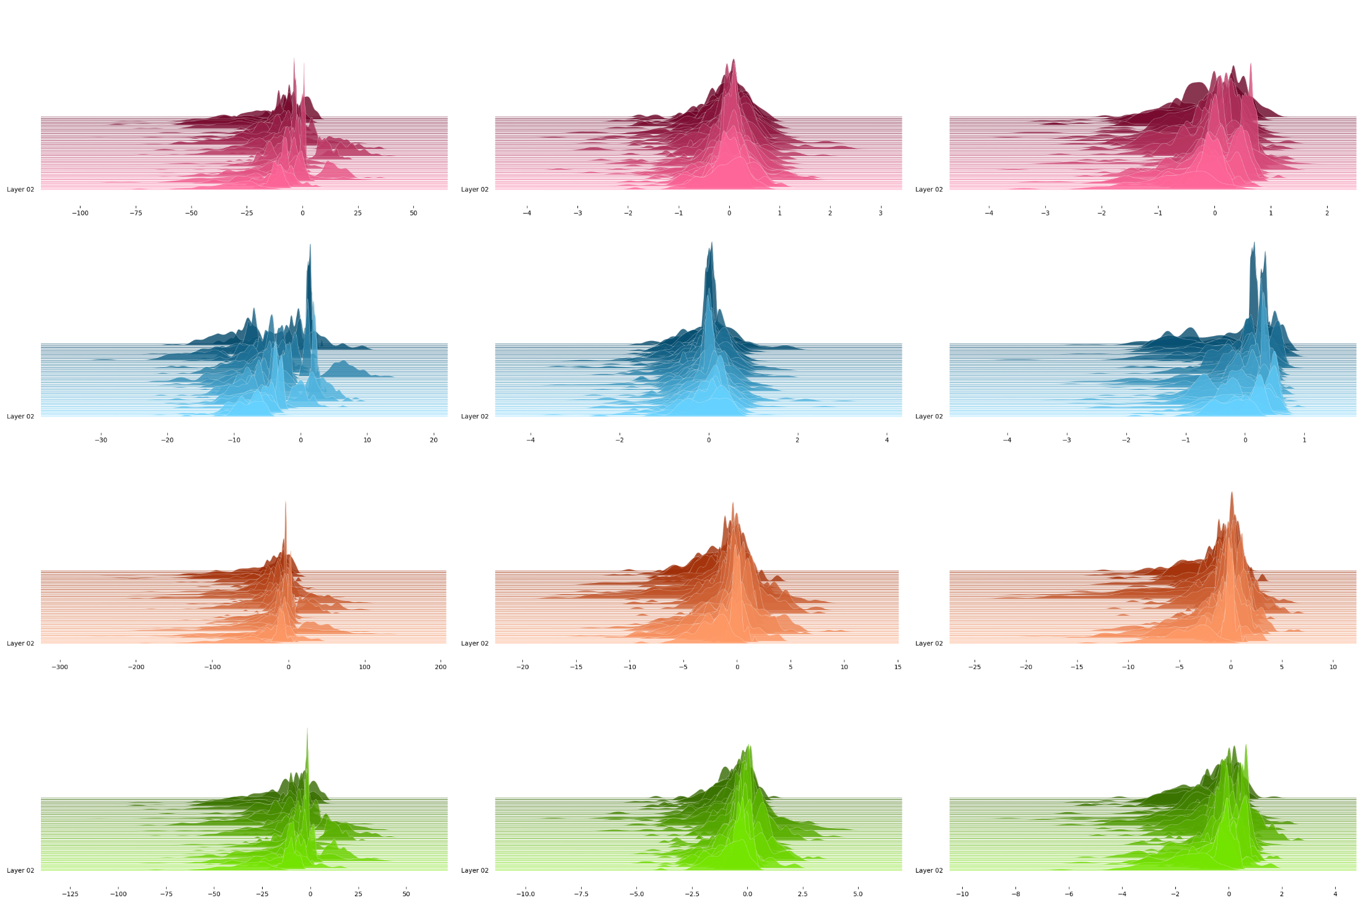

**Values’ distribution of the layer 3. from left to right: BN’s input, pure BN (before affine), BN’s output (after affine). On miniImageNet**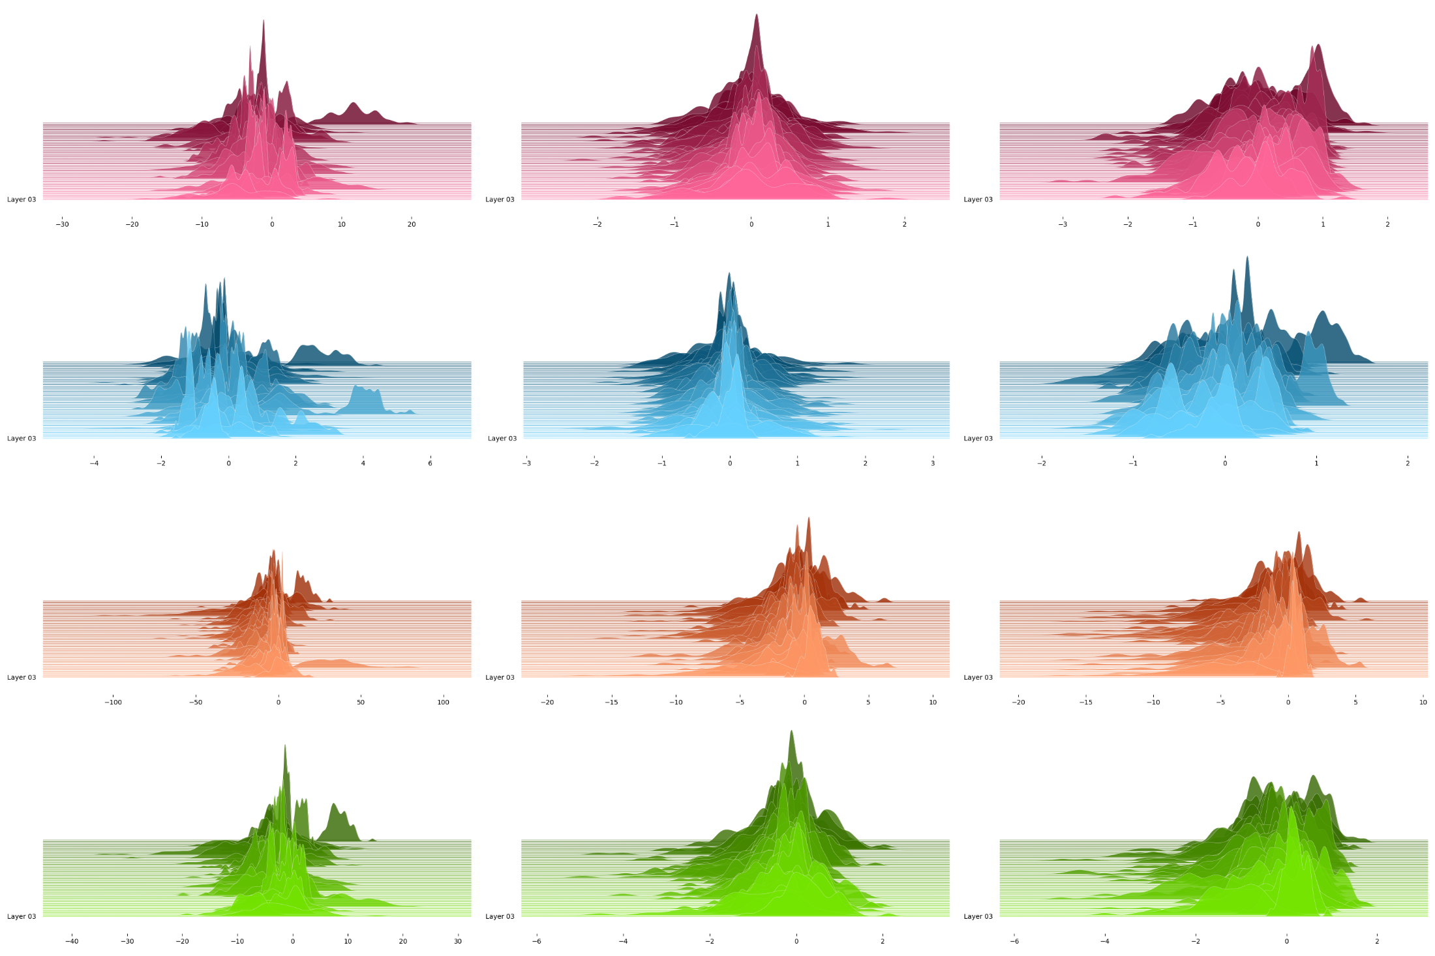

**Values’ distribution of the layer 2 and channel 20. from left to right: BN’s input, pure BN (before affine), BN’s output (after affine). On miniImageNet**